**Conceptual design**

It will be an onboard system which integrates the upgraded A-GPS system ([Assisted-GPS introduction video](https://www.youtube.com/watch?v=Ph9tLBFzxy8)), internet, holographic emitter, basically it keeps the minimal interaction with driver to avoid too much distractions, so driver only gives an order vocally to find an nearest optimal available parking slot by voice and then the system should automatically display a holographic image to indicate the position, also the driver should be able to vocally confirm the payment via internet.

**Functionality**

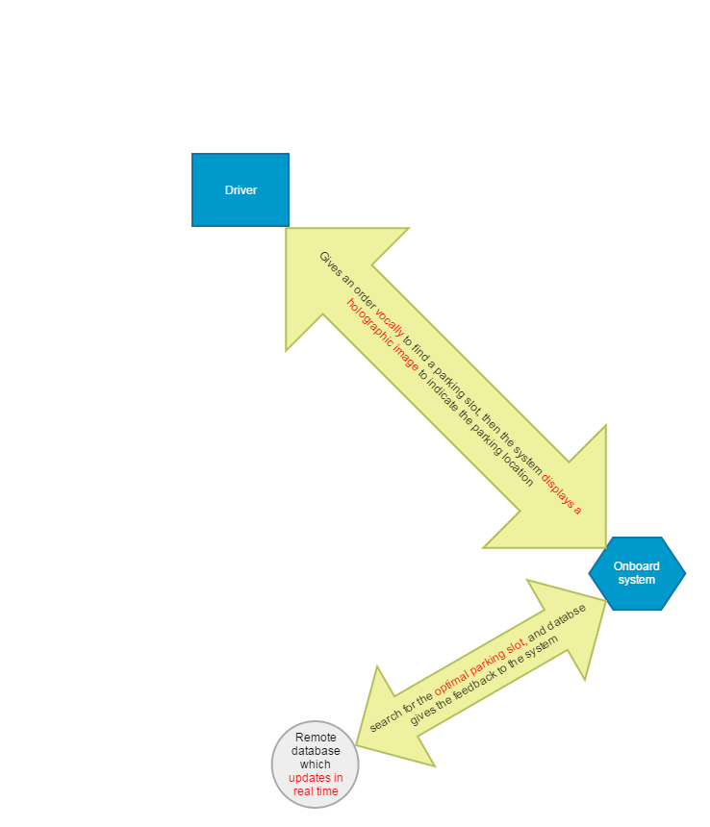

**Appearance**

The system should look like a built-in device which looks like a small GPS device just like this: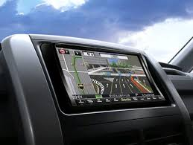 but without the display screen.

and when activated, it should display a holographic dynamic image like the images showed below:

